Spring Core and Maven OUTPUTS

1. Configuring a Basic Spring Application

Step – 1 : Create a Maven project and add spring dependency to pom.xml file.

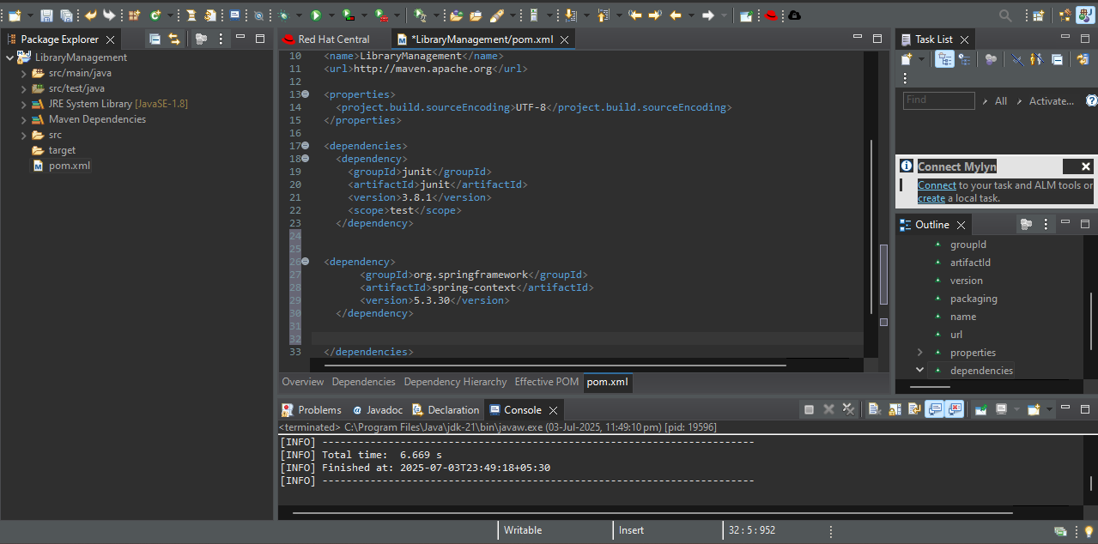

Step – 2 : Create 2 packages repository and service and create a java class in both packages and write code.

BookRepository code :

package repository;

public class BookRepository {

public void saveBook(String bookName) {

System.out.println("Book \"" + bookName + "\" saved to the database.");

}

}

BookService code :

package service;

import repository.BookRepository;

public class BookService {

private BookRepository bookRepository;

public void setBookRepository(BookRepository bookRepository) {

this.bookRepository = bookRepository;

}

public void addBook(String bookName) {

System.out.println("Processing book addition...");

bookRepository.saveBook(bookName);

}

}

MainApp code :

package com.library;

import service.BookService;

import org.springframework.context.ApplicationContext;

import org.springframework.context.support.ClassPathXmlApplicationContext;

public class MainApp {

public static void main(String[] args) {

ApplicationContext context = new ClassPathXmlApplicationContext("applicationContext.xml");

BookService service = (BookService) context.getBean("bookService");

service.addBook("Spring in Action");

}

}

Step – 3 : Write applicationcontext.xml code in resources file

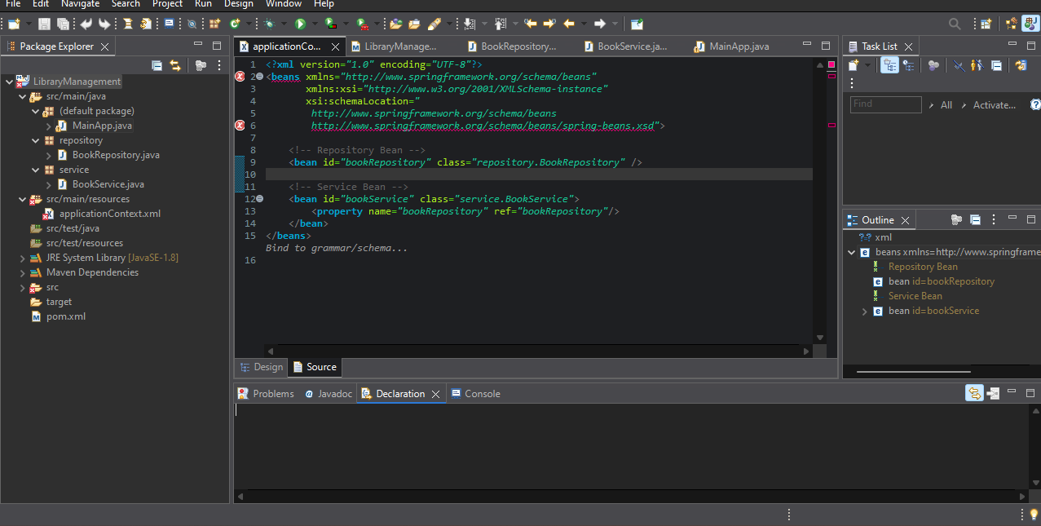

Step – 4 : Run the MainApp.java code as java application

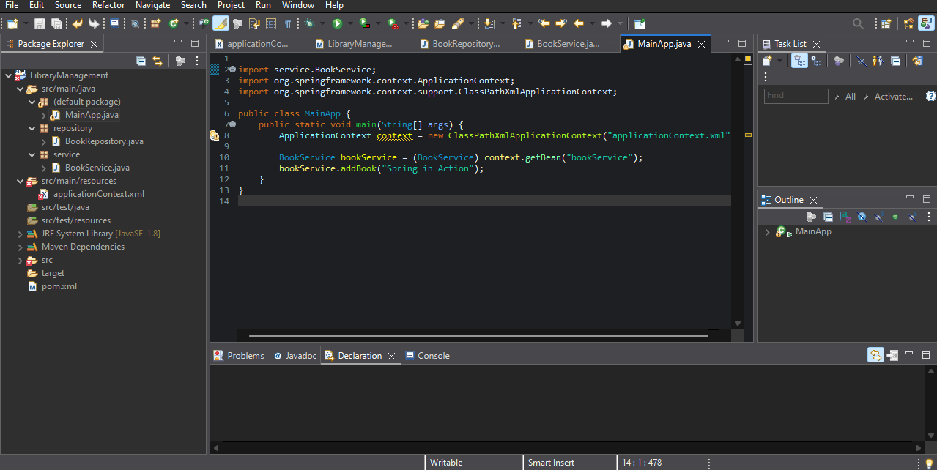

OUTPUT :

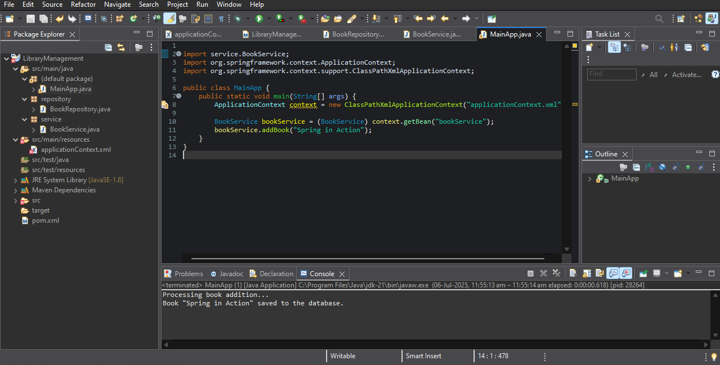

1. **Implementing Dependency Injection**

Step – 1 : Change the code in applicationContext.xml file.

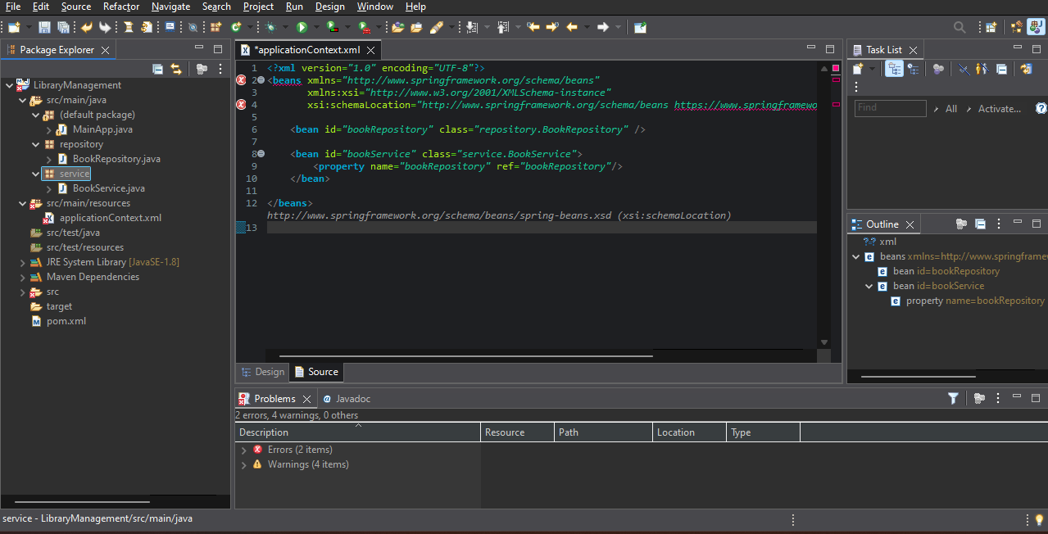

Step – 2 : Add setBookRepository method in BookService class

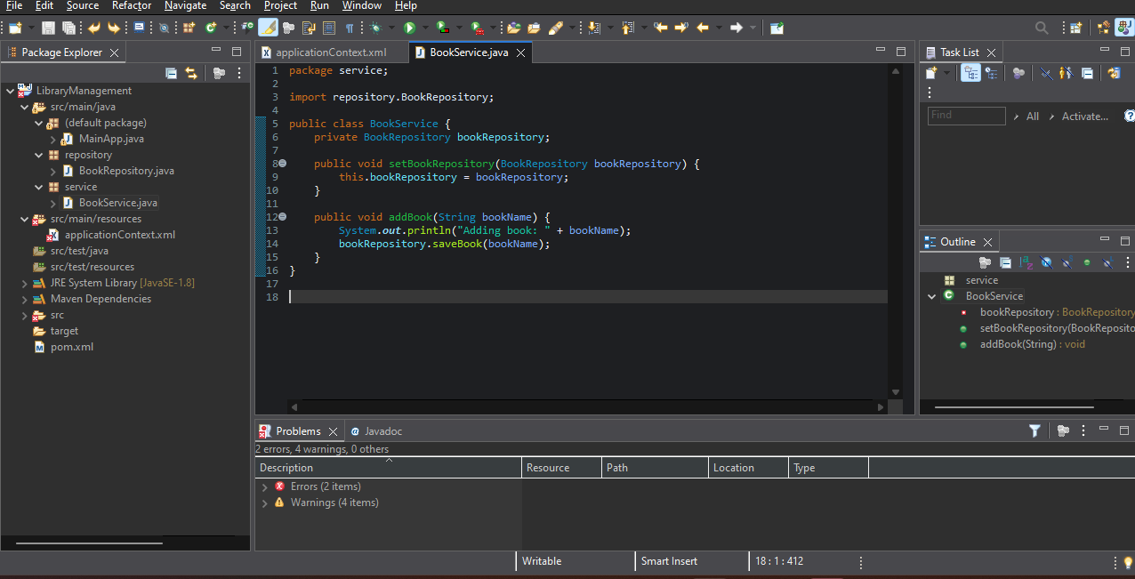

Step – 3 : Change the code of BookRepository.java

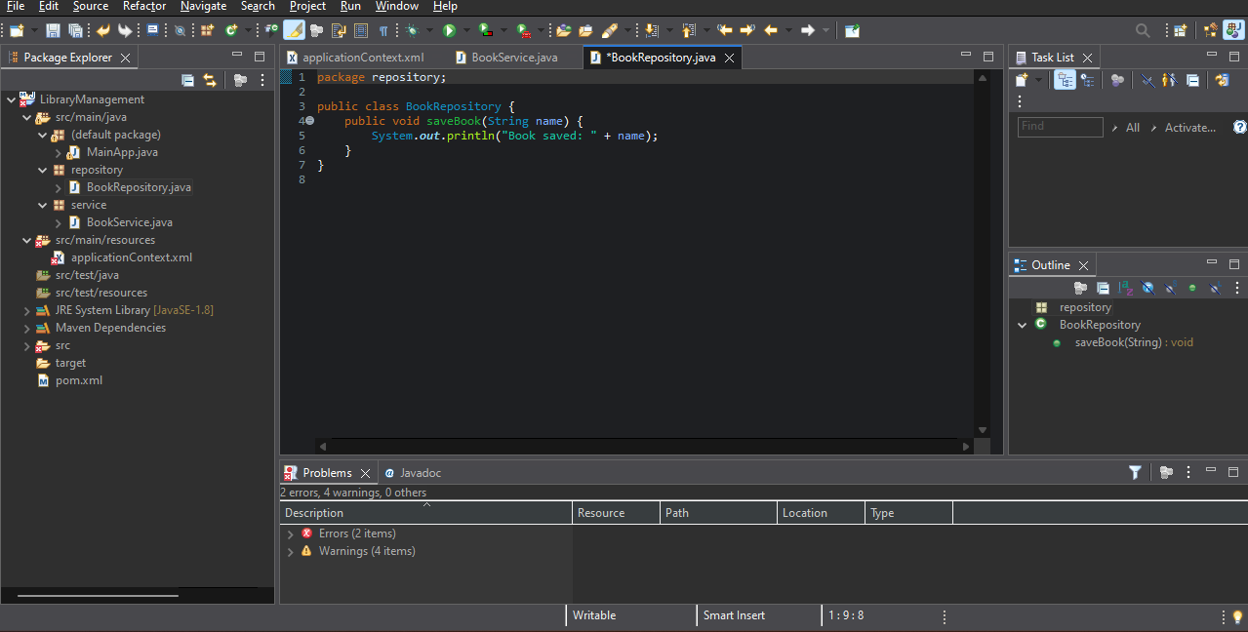

OUTPUT :

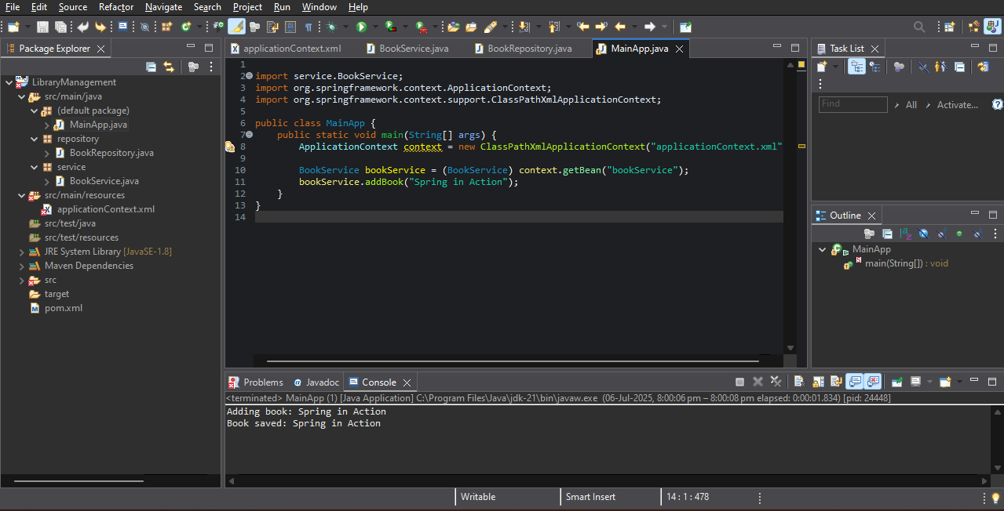

Creating and Configuring a Maven Project

Step – 1 : Create a Maven project and add Spring Context, Spring AOP, and Spring WebMVC and Plugin for Java version 1.8 to pom.xml file.

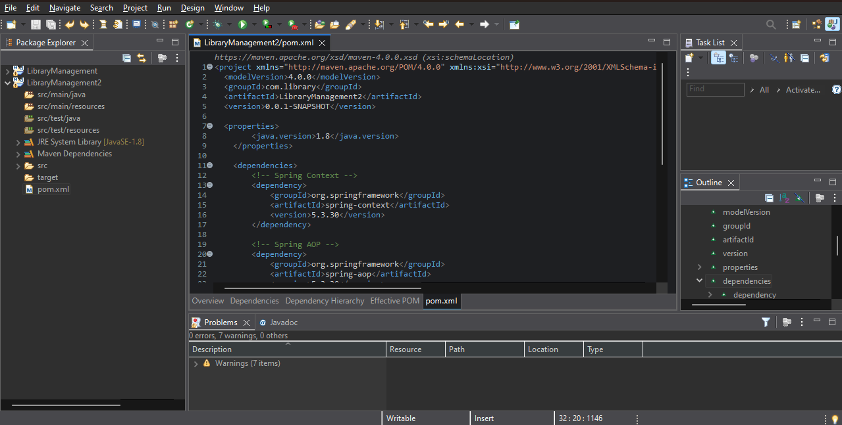

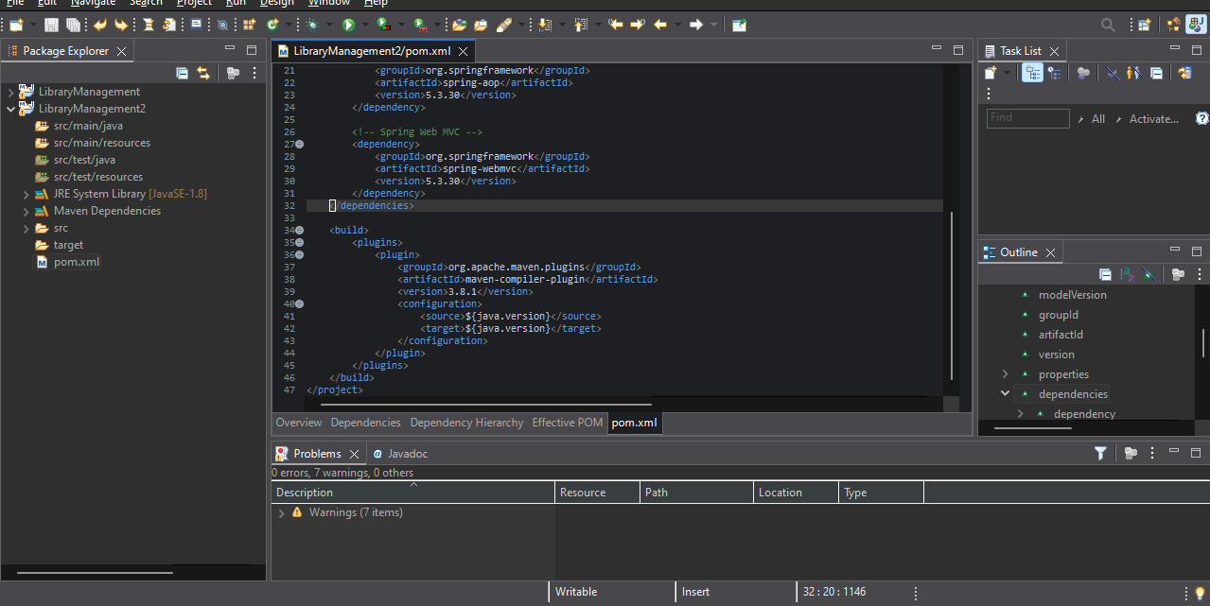

OUTPUT :

Now u have added Spring Context, Spring AOP, and Spring WebMVC and Plugin for Java version 1.8 to your maven project.